Alicia Quental
Period 7
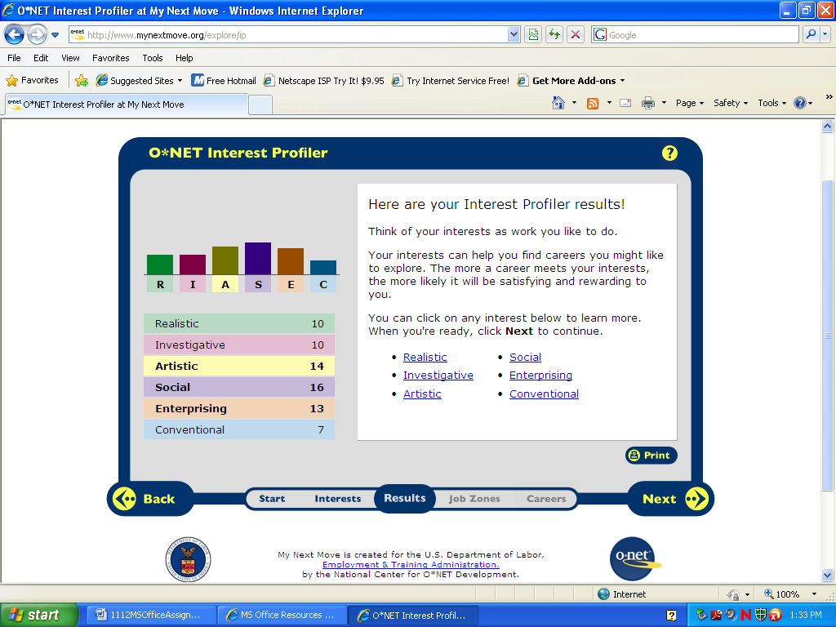

Social: with social being my highest interest on the profiler I do agree with that as my one of my top interests. It explains social as people who like working with others and helping them grow, they like things such as teaching, giving advice and being of service to people. This relates to me because I do enjoy helping other people, mostly children when I can and being of assistance to them when ever needed.

Artistic: The next highest interest for me was artistic, which I also find to be very true about me. An artistic person would go into something like acting music art and design. They like things that don’t involve a set of rules and a person can express themselves through something artistic. I agree with this because when I am bored I will draw/sketch and try to draw things that come to mind. I also love baking and trying to create new decoration on cakes and other things.

Enterprising: this was the lowest of my profiles and I do not agree with this, a person in enterprising likes leading and carrying out businesses, they like leading people and taking risks for profit. I do not think this matches me because I would rather work for someone than be the highest of the group.

Top ten careers:
Social
Nurse
Child care worker
Dental assistant
Teaching
Artistic
Fashion designer
Make up artist
Enterprising
Real estate sales agent
Hair stylist
Cosmetologist

- Nurse
1) Take care of sick and injured people. They give people medicine and treat wounds. Give emotional support to patients and their families. Nurses ask patients about their symptoms and keep detailed records. They watch for signs that people are sick, nurse’s help doctors examine and treat patients.
2) Registered nurses, doctors, health education, human service agents and social workers.
3) Social because it is a job that has constant interaction with adults and children, so you need to know how to effectively work with people.
4) Bachelor's of science degree in nursing (BSN), an associate degree in nursing (ADN), and a diploma. BSN programs, offered by colleges and universities, take about 4 years to complete. ADN programs, offered by community and junior colleges, take about 2 to 3 years to complete. Diploma programs, administered in hospitals, last about 3 years.
5) There is not really any technology training needed in the field of nursing, but it is needed to use a computer to fill out patient information.
6) 2008 the yearly wage for nurses was $65,130
7) There is said to be very good job opportunities in the future for nurses, because they are always needed. They held about 2.6 million jobs in 2008. About 3 out of 5 worked in hospitals
8) Any hospitals, or nursing homes would be willing to higher nurses.
9) It is scatted hours depending on the type of nurses.
10) yes
- Child care worker
1) Child care workers teach and care for children while their parents are away. They make sure children are safe. They help them play games, do art, and read books.
Child care workers need to be energetic, fun, and patient. They help kids gain new skills and learn how to get along with others.
2) Teacher assistants ,Teachers
3) Social, because you need to know how to act with children and how to give them what is needed of you as a care taker
4) Most child care workers can get jobs right after graduating from high school. However, workers in day care centers and schools usually need to get a license from the State where they work. Child care workers learn by watching experienced people. And a child care certificate and college classes will help to get a job.
5) There are no technology skills required in child care.
6) The average yearly wages of child care workers were $20,350 in May 2008. People who worked in elementary and high schools made more than those in day care centers. People with certificates or college degrees often make more money than other people.
7) Jobs for child care workers are projected to grow about as fast as the average for all occupations between 2008 and 2018.
8) Schools, daycares, people out of their homes who need someone to watch over their children.
9) The work time depends on who you are being hired through, it will vary from employer. And the pay also depends on the employer because of work time, and hours.
10) Yes
- Dental Assistant
- Perform a variety of patient care, office, and laboratory duties. They sterilize and disinfect instruments and equipment, prepare and lay out the instruments and materials required to treat each patient, and obtain and update patients' dental records. Assistants make patients comfortable in the dental chair and prepare them for treatment. During dental procedures, assistants work alongside the dentist to provide assistance. They hand instruments and materials to dentists and keep patients' mouths dry and clear by using suction hoses or other devices. They also instruct patients on postoperative and general oral healthcare.

- Medical assistants, Occupational therapist assistants and aides, Pharmacy technicians and aides, and Physical therapist , assistants and aides.
- Social, this is a job that allows you to make people comfortable and feel better because most people do not like the dentist’s office.
- Two-year programs offered in community and junior colleges lead to an associate degree. All programs require a high school diploma or its equivalent, and some require science or computer-related courses for admission. A number of private vocational schools offer 4- to 6-month courses in dental assisting, but the Commission on Dental Accreditation does not accredit these programs.
- Use of computer.
Percentile | 10% | 25% | 50%  (Median) | 75% | 90%
Hourly Wage | $10.92 | $13.23 | $15.98 | $19.12 | $22.63
Annual Wage (2) | $22,710 | $27,520 | $33,230 | $39,780 | $47,07

7) Yes, this a job that will have more job opportunities in the future.
8) Any local dentist offices that need more or new workers.
9) hours depend on the work place, usually 40 hours a week.
10) yes

- Teacher
1) Teachers teach children to read, write, do math, and much more. They use games, videos, computers, and other tools to teach children different subjects. Teachers show students skills. They also explain information. Teachers plan their lessons before they teach, which can take a lot of time. Teachers try to make their lessons easy to understand. They teach things in different ways so that different students can learn in the way that is easiest for them. Teachers might use a chalkboard, a projector, or a computer. They make posters or worksheets before class starts. Teachers plan the schedule for the day.
2) Counselors, Education administrators, Employment interviewers, Librarians, Social workers.
3) Social, because no matter what type of teacher a person is, they need to know how to work with the people they are teaching weather they are teenagers, young children, or kids with learning disabilities. They all have different types of learning so a teacher would need to know how to interact with them.
4) You must have a college degree to be a teacher, you must pass tests in reading, writing, and other subjects. And you have to keep learning. In some States, you have to get a master's degree. You also need computer training in some States. And teachers in public schools must have a teaching certificate and a license to teach. Some are licensed to teach preschool through grade 3. Others are licensed to teach grades 1 through 6 or 8. Some are licensed to teach middle school or high school. Some have a license to teach a special subject.
5) Yes, there is technology training involved in being a teacher because of grading, making and finding worksheets, and organization.
6) Elementary school teachers had average yearly wages of $52,240. Middle school teachers made an average of $52,570 each year, while high school teachers made $54,390 each year.
7) yes, there will be more job opportunities in the future, Job opportunities for teachers over the next 10 years will vary from good to excellent, depending on the place where they live and the subject they teach. Some schools are having trouble finding enough teachers, especially in cities. Today, many schools are looking for math and science teachers as well as teachers who speak a foreign language and who can teach English as a second language.
8) many local schools who are looking to hire new teachers would be willing to hire teachers, especially when it is expected that teaching opportunities are expected to rise over the next 10 years. 4.5 million jobs for teachers in 2008.
9) Hours are full school days, with some free periods and lunch breaks, teachers work seven days a week .
10) yes

- Fashion Designer
1)Fashion designers help create the billions of dresses, suits, shoes, and other clothing and accessories purchased every year by consumers. Designers study fashion trends, sketch designs of clothing and accessories, select colors and fabrics, and oversee the final production of their designers.
2) Artists and related workers ,Commercial and industrial designers ,Floral designers ,Graphic designers ,Interior designers all jobs that are similar to this job title.
3) For this type of job, you would need to be artistic because of the e work that goes into the clothing and the design, you would need to have a good imagination to have a job that requires such artistic work.
4) Need an associate or a bachelor's degree in fashion design. Some fashion designers also combine a fashion design degree with a business, marketing, or fashion merchandising degree, especially those who want to run their own business or retail store. Basic coursework includes color, textiles, sewing and tailoring, pattern making, fashion history, computer-aided design (CAD), and design of different types of clothing such as menswear or footwear. Coursework in human anatomy, mathematics, and psychology also is useful.
5) There is not really a lot of technology training I being in the fashion industry, but there may be little computer work needed.
6) Median annual wages for salaried fashion designers were $61,160 in May 2008. The middle 50 percent earned between $42,150 and $87,120. The lowest 10 percent earned less than $32,150, and the highest 10 percent earned more than $124,780.
7) The best job opportunities will be in design firms that design mass-market clothing sold in department stores and retail chain stores, such as apparel wholesale firms. Few employment opportunities are expected in design firms that cater to high-end department stores and specialty boutiques as demand for expensive, high-fashion design declines relative to other luxury goods and services. Employment of fashion designers is projected to grow by 1 percent between 2008 and 2018.
8) Design firms that design mass-market clothing sold in department stores and retail chain stores, such as apparel wholesale firms.
9) Fashion designers employed by manufacturing establishments, wholesalers, or design firms generally work regular hours in well-lighted and comfortable settings.
10) Yes
- Make Up Artist
1) Theatrical and performance makeup artists apply makeup to enhance performing artists’ appearances for movie, television, or stage performances. They may be self-employed or work directly for a theater, television station, or production company.
2) Barbers, cosmetologists, and other personal appearance workers are jobs that would be found in the same category as a makeup artist.
3) This is job is also something that you would need to be artistic for because it needs to always be clean, well done work. You also need to know how to use proper arrangement of colors.
4) Makeup artists undergo postsecondary training at a school of cosmetology or other specialized institute. Such programs may last several months to a year, and may require a high school diploma for admission. Depending on the State and specific work being performed, makeup artists who also style hair usually require a State license. A background or courses in art and design may be helpful.
5) No training in technology required.
6) Median hourly wages for makeup artists, theatrical and performance, were $12.63 in May 2008.
7) Continued increases in the demand for television programs, movies, and other entertainment will lead to new openings for theatrical and performance makeup artists. At the same time, the increasing use of computer-generated effects in films and the popularity of reality television have limited growth for this occupation. As this is a small occupation, the number of new jobs will be few, despite the faster than average growth.
8) not many close job opportunities nearby.
9) Scattered hours
10) ??

- Real Estate Sales Agent
1) Continued increases in the demand for television programs, movies, and other entertainment will lead to new openings for theatrical and performance makeup artists. At the same time, the increasing use of computer-generated effects in films and the popularity of reality television have limited growth for this occupation. As this is a small occupation, the number of new jobs will be few, despite the faster than average growth.
2) Insurance sales agents, Retail salespersons (car salespersons, etc.), Sales representatives, wholesale and manufacturing Securities, commodities, and financial services sales agents.
3) this is a job in enterprising and you need enterprising skills to have a job like this.
4) Real estate agents must have a license from the State in which they work. To get a license, a person must have graduated from high school. The person must be at least 18 years old and pass a written test. In some States, a person who wants to be a real estate agent must go to a special school for a few months.
5) None required

*I chose these three careers based on the job search research. All of these careers are jobs that deal with working and helping people on a daily basis, which is something I was looking for. Both Nursing and dental assistant were my top choices because the percent growth is higher than most which means there will be plenty of jobs in the future, these also has good pay and a good working environment. Makeup artist was my third choice, because it is also a job which involves working with people. It is not as much pay, and has a little below average percent growth, but still offer jobs when needed. A nurse, a dental assistant and a makeup artist could all be potential jobs I would be interested in doing in the future.

College Board Research
NURSEING
*UMASS Dartmouth
*RIC ( Rhode Island College)
*Salve Regina
_

